Backend Recruitment Task

Goal
Your task is to implement a backend service that will integrate data from an external API (already provided) and return processed results according to specific business rules.
We expect production-quality code: clean, maintainable, and well-documented. Please make reasonable architectural and technical decisions on your own.

Task requirements
You will create a single endpoint GET /cities that will fetch the list of the most polluted cities by country.
This endpoint should:
- Fetch data from our mock API
- Normalise the data.
  - Only return results that are actual cities.
  - Some entries in the mock API are intentionally corrupted or are not cities.
  - The data may have typos, incomplete entries, or completely wrong records.
  - You need to detect and filter these out.
- Enrich the data
  - For each valid city, fetch a short description from the Wikipedia API
  - Add this description field to your returned JSON.
- Return the final result.
The response should be in the following format:
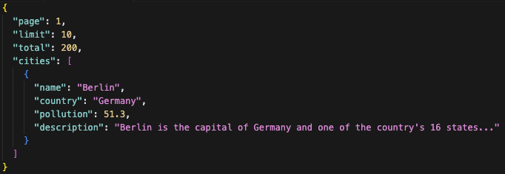

Important Notes
- The mock API has random data corruption (invalid entries, wrong data, non-city values). You must decide how to filter them out logically.
- Wikipedia API and our mock server have rate limits. Avoid unnecessary requests (e.g., caching results in memory).
- Use Node.js (any framework or plain Express is fine).
- Clean, readable, and maintainable code is preferred over “just working” code.

Deliverables
- The source code of your service (GitHub link or ZIP).
- Instructions on how to run it locally (npm install && npm start is fine) or link to the deployed app.
- A short README explaining:
  - How do you determine whether something is a city?
  - Any limitations or assumptions.

Pollution data API
BaseURL: https://be-recruitment-task.onrender.com
Docs: https://be-recruitment-task.onrender.com/docs
Credentials:
Username: testuser
Password: testpass

